Merismopedia Meyen 1839
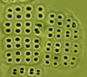
Phylum: Cyanobacteriophyta
Class: Cyanophyceae
Order: Chroococcales

Habitat: planktonic
Distinctive features: sheet-shaped flat colonies of minute spherical to ovoid cells, organized in parallel lines connected by mucilage to form a single-layered rectangular colony. Often the only genus occurring at depth > 20 m
Organization: colonial
Color: light blue-green
Cell shape: spherical or ovoid
Colony shape: rectangular
Cell diameter (D): 0.5 – 4 μm
Biovolume equation: Sphere V, μm³ = 4/3 π (D/2)³
Cells per colony: 4-32 cells, rarely much larger

Morphological features: colonies of spherical or ovoid cells, hemispherical after division, organized in parallel rows to form a single-layered flat sheet of cells (Plate 1). Often with several subcolonies remaining together. Cells are embedded in colorless mucilage that is unseen unless stained (Plate 2). Species in this genus divide in only two directions, creating the characteristic grid-like pattern. Reproduction is by disintegration of colonies. Several different morphological types occur in Lake Kinneret, their allocation to species is not always clear and needs confirmation by DNA sequencing. The most common species occurring in Kinneret is a species of very small cells, < 1 µm diameter, historically referred to as M. minima Beck 1897. But according to Komarek and Anagnostidis (1999) M. minima is subaerophytic on wet rocks mainly in mountains, rarely metaphytic in clear mountain springs. They suggest that similrly looking planktonic types may belong to another species, M. warmingiana Lagerheim 1883. So it is possible that our common Merismopedia was misidentified at the species level. Other species occurring in Lake Kinneret include M. punctata (Plate 1), M. glauca (Plate 2), and two additional unidentified to species level (Plates 3, 4).
Plate 1. Merismopedia punctata. An unusually large colony (most colonies are of up to 64 cells) Photo by Alla Alster.
Plate 2. Merismopedia glauca. The usually spherical cells are in division and look here close to being rectangular. The translucent mucilage is dyed with Toluen Blue. Photo by Alla Alster.
Plate 3. Merismopedia sp. 1. A species of densely packed cells. Photo by Alla Alster.

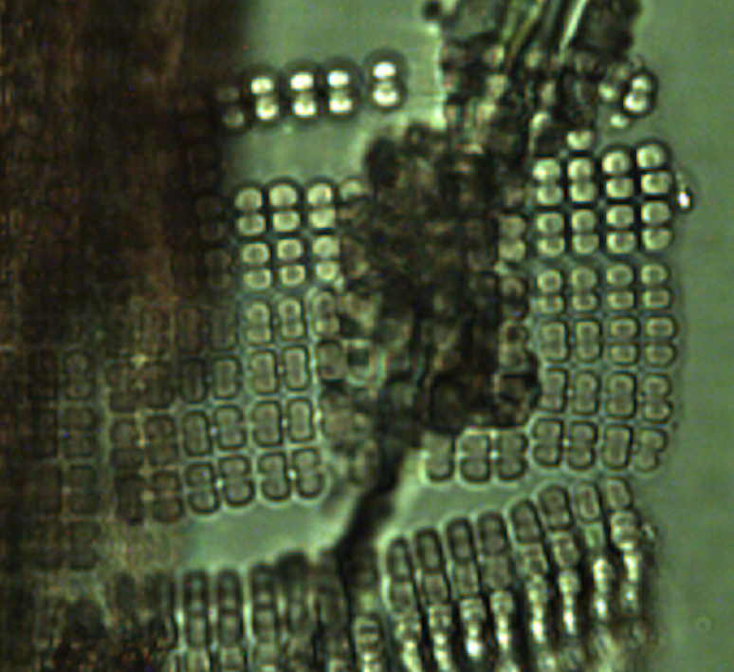
Plate 4. Merismopedia sp. 2. Photo by Alla Alster.

Ecology: Merismopedia spp. are abundant in winter, from November to January (Fig. 1, 2), when they are found in hundreds of colonies/mL (Fig. 1) and thousands of cells/mL (Fig. 2) at all depths of the water column. But due to the minute cell size their contribution to total phytoplankton biomass is negligible. In summer, when the lake is stratified, Merismopedia spp. are absent in the epilimnion although they may be found in the metalimnion, near or below the thermocline. Often they are the only phytoplankton taxon found in samples from 30 m depth.
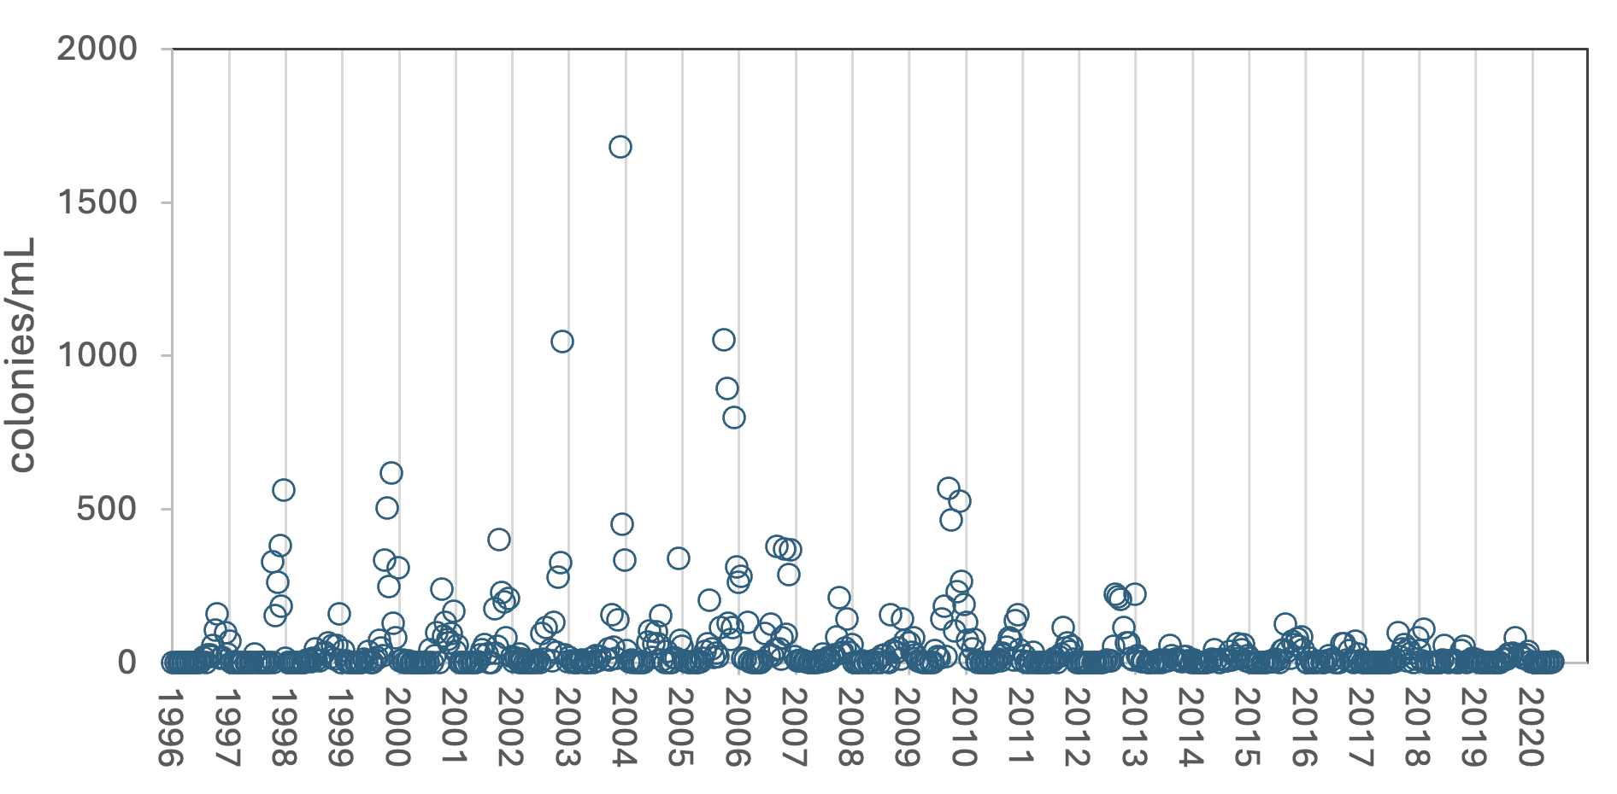
Figure 1. Time series of Merismopedia minima mean epilimnion abundance (colonies mL⁻¹), Lake Kinneret, 1996-2020. The distinct drop in abundance from January 2013 onwards is attributed to the change of Analyst, from Analyst 5 (Tatiana Fishbein) to Analyst 6 (AllaAslter) – the later identified and counted most of the same organisms under a different name and code.
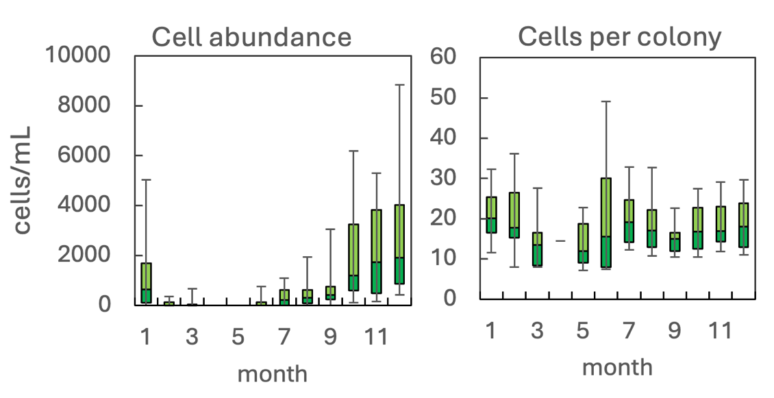
Figure 2. The annual pattern of water column cell abundance (left) and number of cells per colony (right) of Merismopedia minima, based on data for 1996-2013 (Analyst 5). Statistics shown are: median – middle line; 25th to 75th percentiles – box content; 90th and 10th percentiles - top and bottom bars, respectively.

Cite this record as:
Tamar Zohary, Alla Alster. [Date when Item was last updated]. Electronic publication. Israel Oceanographic & Limnological Research. [Date when last accessed].
Further reading:
Komarek J and Anagnostidis K. 1999. Cyanoprokaryota: Chroococcales. In Susswasser Flora von Mitteleuropa 19/1. Gustav Fischer , Jena 1-548.

